**CONTADOR 3 BITS**

|  |  |  |  |  |  |  |  |  |  |  |  |  |
| --- | --- | --- | --- | --- | --- | --- | --- | --- | --- | --- | --- | --- |
| TABLA DE TRANSICION DE ESTADOS | | | | | | | | | | | | |
| Edo Actual | | |  | **Edo Siguiente** | | | **FF2** | | **FF1** | | **FF0** | |
| A | B | C | D | A+ | B+ | C+ | J2 | K2 | J1 | K1 | J0 | K0 |
| 0 | 0 | 0 | 0 | 0 | 0 | 1 | 0 | X | 0 | X | 1 | X |
| 0 | 0 | 1 | 0 | 0 | 1 | 0 | 0 | X | 1 | X | X | 1 |
| 0 | 1 | 0 | 0 | 0 | 1 | 1 | 0 | X | X | 0 | 1 | X |
| 0 | 1 | 1 | 0 | 1 | 0 | 0 | 1 | X | X | 1 | X | 1 |
| 1 | 0 | 0 | 0 | 1 | 0 | 1 | X | 0 | 0 | X | 1 | X |
| 1 | 0 | 1 | 0 | 1 | 1 | 0 | X | 0 | 1 | X | X | 1 |
| 1 | 1 | 0 | 0 | 1 | 1 | 1 | X | 0 | X | 0 | 1 | X |
| 1 | 1 | 1 | 0 | 0 | 0 | 0 | X | 1 | X | 1 | X | 1 |
| 0 | 0 | 0 | 1 | 1 | 1 | 1 | 1 | X | 1 | X | 1 | X |
| 1 | 1 | 1 | 1 | 1 | 1 | 0 | X | 0 | X | 0 | X | 1 |
| 1 | 1 | 0 | 1 | 1 | 0 | 1 | X | 0 | X | 1 | 1 | X |
| 1 | 0 | 1 | 1 | 1 | 0 | 0 | X | 0 | 0 | X | X | 1 |
| 1 | 0 | 0 | 1 | 0 | 1 | 1 | X | 1 | 1 | X | 1 | X |
| 0 | 1 | 1 | 1 | 0 | 1 | 0 | 0 | X | X | 0 | X | 1 |
| 0 | 1 | 0 | 1 | 0 | 0 | 1 | 0 | X | X | 1 | 1 | X |
| 0 | 0 | 1 | 1 | 0 | 0 | 0 | 0 | X | 0 | X | X | 1 |

AB

CD

|  |  |  |  |  |
| --- | --- | --- | --- | --- |
|  | 00 | 01 | 11 | 10 |
| 00 | 0 | 0 | X | X |
| 01 | 1 | 0 | X | X |
| 11 | 0 | 0 | X | X |
| 10 | 0 | 1 | X | X |

|  |  |  |  |  |
| --- | --- | --- | --- | --- |
|  | 00 | 01 | 11 | 10 |
| 00 | 0 | X | X | 0 |
| 01 | 1 | X | X | 1 |
| 11 | 0 | X | X | 0 |
| 10 | 1 | X | X | 1 |

J2 = BC + D

J1 = C + D

|  |  |  |  |  |
| --- | --- | --- | --- | --- |
|  | 00 | 01 | 11 | 10 |
| 00 | 1 | 1 | 1 | 1 |
| 01 | 1 | 1 | 1 | 1 |
| 11 | 1 | X | X | X |
| 10 | X | X | X | X |

J0 =

|  |  |  |  |  |
| --- | --- | --- | --- | --- |
|  | 00 | 01 | 11 | 10 |
| 00 | X | X | 0 | 0 |
| 01 | X | X | 0 | 1 |
| 11 | X | X | 0 | 0 |
| 10 | X | X | 1 | 0 |

|  |  |  |  |  |
| --- | --- | --- | --- | --- |
|  | 00 | 01 | 11 | 10 |
| 00 | X | 0 | 0 | X |
| 01 | X | 1 | 1 | X |
| 11 | 1 | 0 | 0 | X |
| 10 | X | 1 | 1 | X |

|  |  |  |  |  |
| --- | --- | --- | --- | --- |
|  | 00 | 01 | 11 | 10 |
| 00 | X | X | X | X |
| 01 | X | X | X | X |
| 11 | X | 1 | 1 | 1 |
| 10 | 1 | 1 | 1 | 1 |

K1 = + D + C

K2 = BC + D

K0 =

**CIRCUITO IMPLEMENTADO**

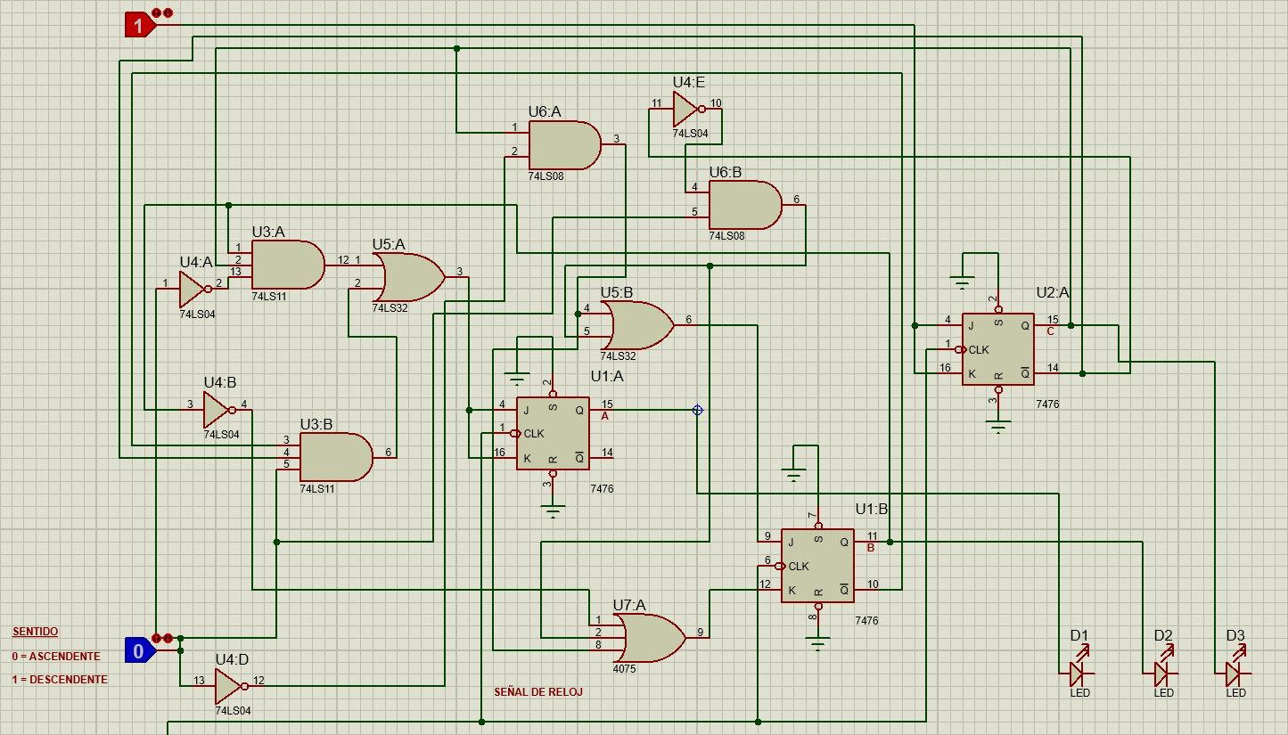

RESULTADO:

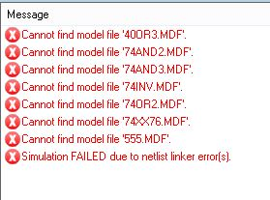

Al intentar correr la simulación me topé con estos errores que no supe cómo resolver…

Intentaré hacerlo con otro simulador.

ALUMNO: Omar Jovany Hernández Sánchez

MATRÍCULO: 34 41 87